Travis S Waggoner

Southern New Hampshire University

CS-360

05/22/2022

Android Studio Setup and Button

Layout

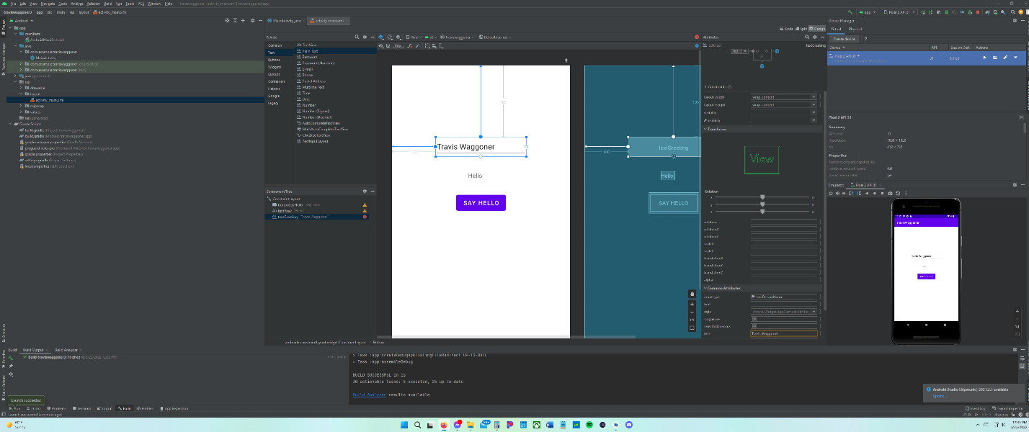

Code Main Activity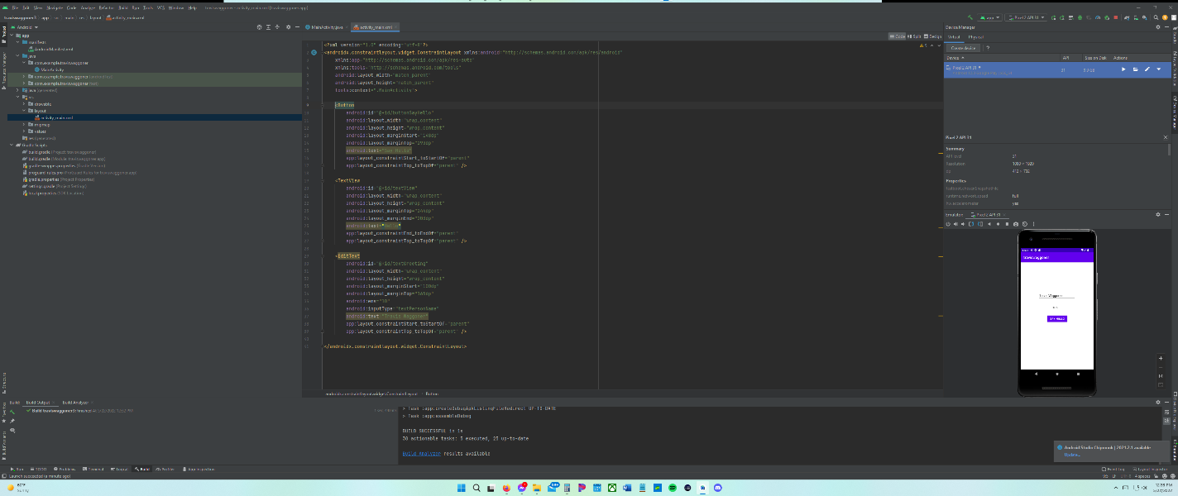

Challenges

Some of the challenges I faced was getting the project set up correctly with the right template and settings. The next section that took the longest overall is the issue with setting the phone up to be utilized with the program to test the project. This made make sure the code was correct almost impossible. I simple issue I ran into was how to get the code to me show instead of the design function. While the design function was useful it would not allow me to change the label of the function. The next challenge I faced was understanding how the labels for the objects was meant to be identified in the program. This led to some challenges because I needed to figure out was the correct Id method was after I had already changed the code. The last challenge was understanding how to constrain the objects to where they need to be so that they would show up in the correct orientation for the program. This last challenge brought my understanding of where everything is and how they work with one another together. All together it was mostly understanding how the overall function of the program worked rather than the overall coding of the application, which the program makes simple.